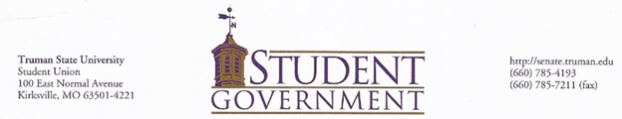

Student Government Resolution xxxx
A Resolution Allocating the Budget for Truman Transformations
Sponsored by President JJ Dorrell and Vice President Christy Crouse

WHEREAS,
• The Student Government is the official governing body of the Student Association and exists to represent the present and long term best interest of the Student Association in the formulation of University policy and in the fulfillment of the University mission; and
• Truman Transformations 2016 takes place on August 17-21; and
• Truman Transformations is an orientation program for new first year students at Truman with the purpose of helping new students adapt to living at Truman State University after leaving home; and
• Truman Transformations is the first opportunity for new students to interact with members of the University through events such as The College Cup Challenge, Major Day, Dawg Fest, Montage, Mocktails, Movie Night, the Truman Lecture and much more; and
• Truman Transformations gives new incoming students the opportunity to attend information sessions on topics such as Athletics, ROTC, Study Abroad, Pickler Memorial Library, and alcohol awareness; and
• Student Government annually works to promote awareness of the role it has on campus through a presence during Truman Transformations, in order to encourage new students to participate in Student Government; and
• Student Government will work with the International Student Office to foster more integration during Truman Transformations between incoming domestic and international freshmen to intermix and create a diverse community; and
• It is valuable for Student Government to continue to provide giveaways for new students to promote Student Government’s name on campus, this would cost approximately $2,500; and
• Members of Student Government will need to move back early to promote participation and awareness in Student Government, which would cost approximately $900; and
• Student Government intends to sponsor several events for the Center for Student Involvement which will cost approximately $300; and
• Student Government apparel—such as name tags, polos and t-shirts—will need to be purchased and will cost approximately $950; and
• Miscellaneous expenses may be needed to cover any unforeseen cost associated with Truman Transformations, which is budgeted for no more than $200.

THEREFORE BE IT RESOLVED THAT,
• The Student Government of Truman State University shall spend no more than $4,850 to fund Student Government activities during the 2016 Truman Transformations program.

THE STUDENT GOVERNMENT OF TRUMAN STATE DIRECTS THAT,
• Additional copies of this resolution be disseminated to Laura Bates, the Director of the Center for Student Involvement; Office of Special Collections; and the Truman Media Network.

Approved by: Unanimous Consent 5/1/16

President of the Student Association, JJ Dorrell

